Topics: Descriptive Statistics and Probability

- Look at the data given below. Plot the data, find the outliers and find out

Name of company | Measure X
Allied Signal | 24.23%
Bankers Trust | 25.53%
General Mills | 25.41%
ITT Industries | 24.14%
J.P.Morgan & Co. | 29.62%
Lehman Brothers | 28.25%
Marriott | 25.81%
MCI | 24.39%
Merrill Lynch | 40.26%
Microsoft | 32.95%
Morgan Stanley | 91.36%
Sun Microsystems | 25.99%
Travelers | 39.42%
US Airways | 26.71%
Warner-Lambert | 35.00%

Name Of companies with respect to X

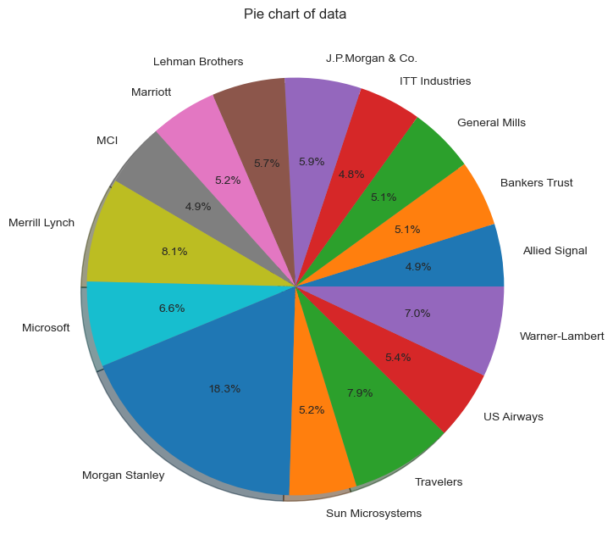

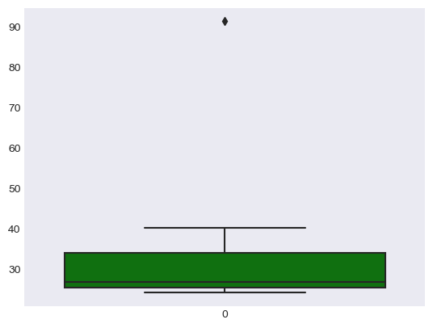

The following is the outlier in the boxplot: Morgan Stanley 91.36%

The values of Mean, Standard deviation & Variance are below:

Mean = 33.271333

Standard deviation = 16.945401

Variance = 287.1466123809524

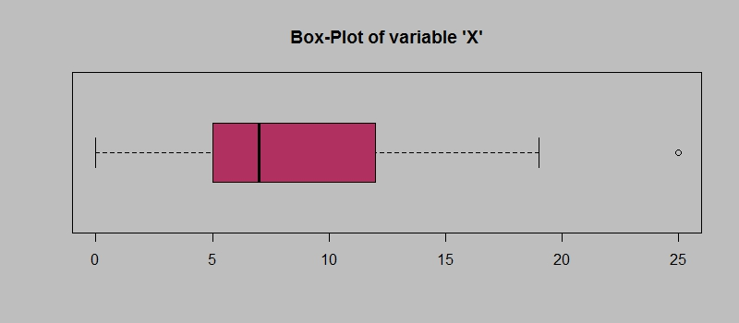

Answer the following three questions based on the box-plot above.
1) What is inter-quartile range of this dataset? (please approximate the numbers) In one line, explain what this value implies.
Ans:
Approximately (first Quantile Range) Q1 = 5, (Third Quantile Range) Q3 = 12, Median (Second Quantile Range) = 7
Inter-Quartile Range (IQR) = Q3 – Q1 = 12 - 5 = 7.
Second Quartile Range is the Median Value

2)What can we say about the skewness of this dataset?
Ans:
Median is closer to the Bottom of the Box and the whisker is also shorter on the lower end of the Box. The Data is Positively Skewed (Right Skewed).

3)If it was found that the data point with the value 25 is actually 2.5, how would the new box-plot be affected?
Ans:
In that case there would be no Outliers on the given dataset, because of the outlier the data had positive skewness it will reduce and the data will normal distributed

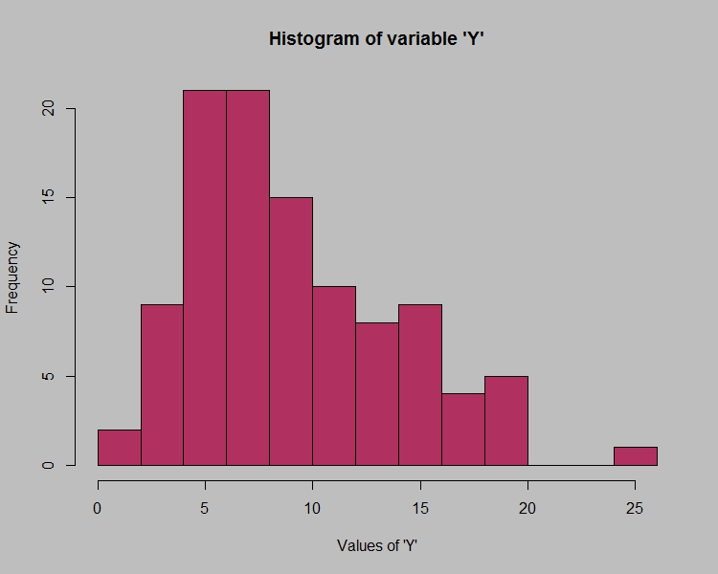

Answer the following three questions based on the histogram above.
- Where would the mode of this dataset lie?
Ans: The mode of this data set lies in between 5 to 10 and approximately between 4 to 8.

- Comment on the skewness of the dataset.
Ans: Right Skewed (Positive skewness). Mean>Median>Mode.
- Suppose that the above histogram and the box-plot in question 2 are plotted for the same dataset. Explain how these graphs complement each other in providing information about any dataset.
Ans: They both are right-skewed and both have outliers, the median can be easily visualized in box plot whereas in histogram mode is more visible.

- AT&T was running commercials in 1990 aimed at luring back customers who had switched to one of the other long-distance phone service providers. One such commercial shows a businessman trying to reach Phoenix and mistakenly getting Fiji, where a half-naked native on a beach responds incomprehensibly in Polynesian. When asked about this advertisement, AT&T admitted that the portrayed incident did not actually take place but added that this was an enactment of something that “could happen.” Suppose that one in 200 long-distance telephone calls is misdirected. What is the probability that at least one in five attempted telephone calls reaches the wrong number? (Assume independence of attempts.)
Ans: IF 1 in 200 long-distance telephone call are getting misdirected.
Probability of call misdirecting = 1/200.
Probability of call not misdirecting = 199/200.

The probability of at least 1 in 5 attempted telephone calls reaches the wrong number
Number of Calls = 5.

n = 5

p = 1/200

q = 199/200

P(X) = at least one in five attempted telephone calls reaches the wrong number

P(x) = ⁿCₓ pˣ qⁿ⁻ˣ
P(X) = ( nCx ) (p^x) (q^n-x) # nCr = n!/r! * (n-r)!
P (1) = (5C1) (1/200)ˆ1 (199/200)ˆ5-1
P (1) = 0.0245030

- Returns on a certain business venture, to the nearest $1,000, are known to follow the following probability distribution
x | P(x)
-2,000 | 0.1
-1,000 | 0.1
0 | 0.2
1000 | 0.2
2000 | 0.3
3000 | 0.1

- What is the most likely monetary outcome of the business venture?
- Is the venture likely to be successful? Explain
- What is the long-term average earning of business ventures of this kind? Explain
- What is the good measure of the risk involved in a venture of this kind? Compute this measure

Ans:
E(X) = Sum X*P(X) | E(Xˆ2) = Xˆ2*P(X)
-200 | 400000
-100 | 100000
0 | 0
200 | 200000
600 | 200000
300 | 900000
Total: 800 | 2800000

- What is the most likely monetary outcome of the business venture?
Ans:
The most likely monetary outcome of the business venture is $2000
As for $2000 the probability is 0.3 which is maximum which is maximum as compared to others.

- Is the venture likely to be successful? Explain
Ans:
Yes, the probability that the venture will make more than 0 or a profit
p(x>0) + p(x>1000) + p(x>2000) + p(x=3000) = 0.2+0.2+0.3+0.1 = 0.8 this states that there is a good 80% chances for this venture to be making a profit

- What is the long-term average earning of business ventures of this kind? Explain
Ans:
The long-term average is Expected value = Sum (X * P(X)) = 800$ which means on an average the returns will be + 800$

- What is the good measure of the risk involved in a venture of this kind? Compute this measure
Ans:
The good measure of the risk involved in a venture of this kind depends on the Variability in the distribution. Higher Variance means more chances of risk
Var (X) = E(X^2) –(E(X)) ^2
= 2800000 – 800^2
= 2160000

